Other Regarding Preferences:
Some Key Papers

Other regarding preferences exist; people do not care just about their own payoffs, but those of others. This point has been observed (at least formally) since the introduction of the ultimatum game in experimental economics. Two of the more famous models used to explain subjects’ choices in the ultimatum game (i.e., why there were a large number of rejections at all, but especially on relatively unequal allocations) are the Bolton-Ockenfels and Fehr-Schmidt models (hereafter BO and FS). The models take the following forms:

BO: $U_{i}\left(X\right)=U(x_{i}, \frac{x_{i}}{\sum{x_{k}}})$
FS: $U_{i}\left(X\right)= x_{i}- \frac{α}{n-1}\sum_{k ≠i}{max⁡(}x_{k}- x_{i},0)-\frac{β}{n-1}\sum_{k ≠i}{max⁡(}x_{i}- x_{k},0)$

Note that the BO model states that agents strictly prefer a relative payoff that is equal to the average payoff. FE is not quite so restrictive. This is because it is assumed that for all agents$α> β$. In fact, for the simple ultimatum games, the responder’s actions depend on these parameters in a specific way. If the offer from the proposer is less than $\frac{α_{R}}{1+2α_{R}}$ then the agent should reject where $α_{R}$ is the envy parameter of the responder. Therefore, when offering a higher than classical sub-game perfect amount, it is likely that the proposer is considering the range of $α_{R}$of the other player.

There have other attempts to explain other regarding preferences theoretically since these papers were written. They do, however, remain heavily used as a starting point for discussing the actions of agents in simple settings similar to the ultimatum and dictator games. The rest of this short series of paper reviews will look at how the various settings, outside options, and possible peer viewership might influence the actions people make when making choices which have social implications.

Kagel and Wolfe (2002)

This paper seeks to look at what would happen in a three person ultimatum game and if the predictions of both the BO and FS models which so nicely organized the data in two person versions would still do so here. The structure of the game, though slightly more complicated, is still rather simple. Three subjects are grouped; one is selected to be the proposer. She proposes an allocation between herself and the two other group members. One of the two other members is randomly selected to be the responder and can either accept the allocation or reject it. If she accepts it, all parties are paid and if she rejects it both the responder and the proposer get zero, but the third party gets a payoff. This format is a simple extension from the two to three person ultimatum game and will allow for a clean test of both the BO and FS models.
If the third party payoff is high enough, then all positive offers should be accepted by the responder. This is because if they are rejected, then the subject is giving up own income and creating very sharp income inequality. They vary the third person’s payment between sessions to be either $0, $1, $3, and $12 all in games where the proposer is allocating $15. If the player rejects any time there is a positive payment for the non-responder when she rejects, then BO model does not capture the behavior. Likewise, a $12 consolation prize should eliminate all rejections within the FS model.
They find overall rejection rates between 15% and 22% when there is a positive consolation prize and 21% when there is no consolation prize. They don’t find any strong different in the way responders act as the size of the consolation prize changes (indicating that FS might not be correct). This outcome puzzled the authors so much that they developed a negative third party treatment. If the selected responder rejected the offer from the proposer, then the third player loses $10. This set-up does not induce responders to reject less often.
Why does this happen? Well, one could argue (as the authors and even FS do) that the reference point to which the responder is deciding what to do might not include the other potential responder. This is, in fact, quite surprising as that person is in the identical position as the selected responder.

Dana, Cain, and Dawes (2006)
This paper takes a different approach to studying pro-social behavior than those before it; the authors are interested in how much people will try to avoid engaging in potentially pro-social situations. They conclude, maybe unsurprisingly, that giving often reflects a desire not to violate others’ expectations rather than a concern for others’ welfare per se. Note that is idea isn’t new. In some ways, the FS model incorporates the idea that the proposer should consider the receiver’s inequality parameters and these could be thought of as her expectations about what is socially right.
The structure of the basic game is simple. Consider a standard dictator game where there is $10 to be allocated between the dictator and the other player. Add to this game, a pre-play decision that the dictator can take to exit the game without the knowledge of the other player. Subjects played this game at the end of an experimental session. The procedures were as follows: Dictators were given written instructions for both themselves and receivers and asked to allocate the $10. After this, another set of papers were passed out so that they were asked if they would like to take $9, and leave with both the instructions in hand so that the receiver for which they were paired would never see the game (and consequently the allocations). If they said yes, they left and were paid. If no, then the experimenter collected the allocations from the instructions and passed them out to the matched receiver. Either way, the dictator was free to leave after making her second choice.
Twenty-eight percent of dictators took the option to exit the game. The interesting finding is that the distribution of gifts of those who exit looks very similar to that of those who choose to play the game. That is, it is not just those who would appear to be greedy to the receivers who choose to leave, but rather a swath of the whole distribution that choose to do so. There a multitude of things which drive this result, leading the experimenters develop another treatment. The new treatment basically is a private dictator game where the receiver has no idea that they played the game; any positive amount is just added to the show up payment or results from the other games without announcing that it came from the dictator game. In this way, the dictator should not have to worry about being judged. Here, the expectation is less dictators choose to leave (4% do). They conclude that, in addition to monetary concerns, subjects are also motivated to take the action they think that others expect them to take.
Andreoni and Bernheim (2009)
Partially inspired by the work by Dana, Cain, and Dawes (2006), this paper seeks to help clarify their results and to add a new theory to how agents acted in situations where they knowingly influence the payoffs of others. They are that a division of 50-50 is a pervasive social norm in many economic environments. They argue that it is not the case the people value fairness, but that people value being observed as being fair. This statement is similar to the findings from DCD. I will not go much into the theoretical modeling, but the model is flexible enough to be used in a variety of contexts.
The experiment to test their theory is set-up as follows. Subjects are split into pairs and each pair is to split $20. At the end of the experiment, all parties and outcomes are identified to help enhance the effects of social image. There were different sets of conditions. Simply there was one where the gift $x$ was forced to be either $20 or $0 or $1 and $19 with varying probabilities. I will explain the $0 and $20 dollar game. Subjects are informed of their private number (1 through 4) and in some rounds they are allowed to make a choice and others their choice is forced based on their private number. If their choice is forced, then with equal probability they will be paid $20 or $0 and their partner will receive $0 or $20, respectively. In this way, if the subject wanted plausible deniability of being greedy and there was some probability that their choice was forced, then they can offer their partner nothing (as with some probability that will naturally occur). If the subjects offer anything other than $0 or $20 to their partner, then their partner (and the rest of the room) will observe this outcome as taking place. Subjects follow the pattern associated with plausible deniability of being the unfair distributer (see figure below).
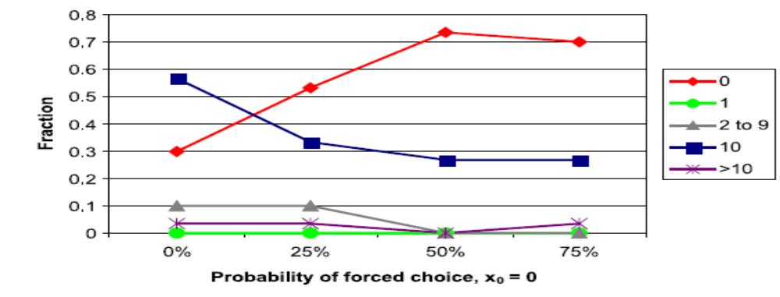
Figures for Kagel and Wolfe
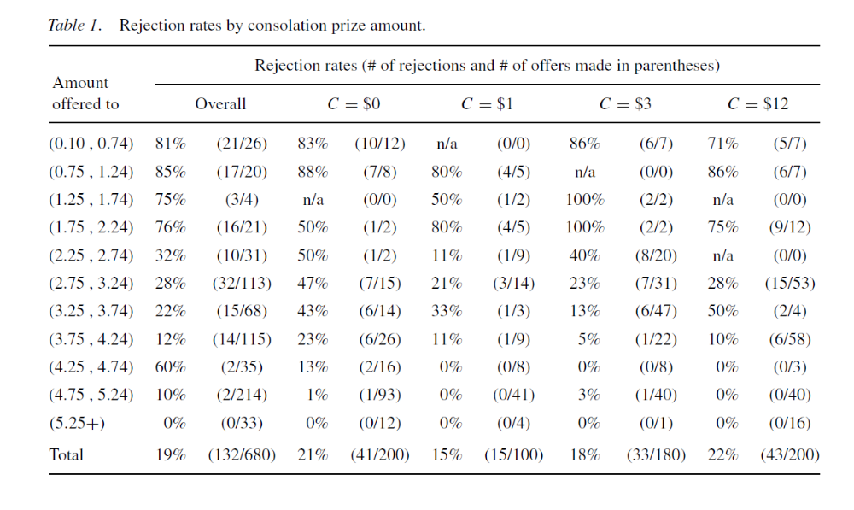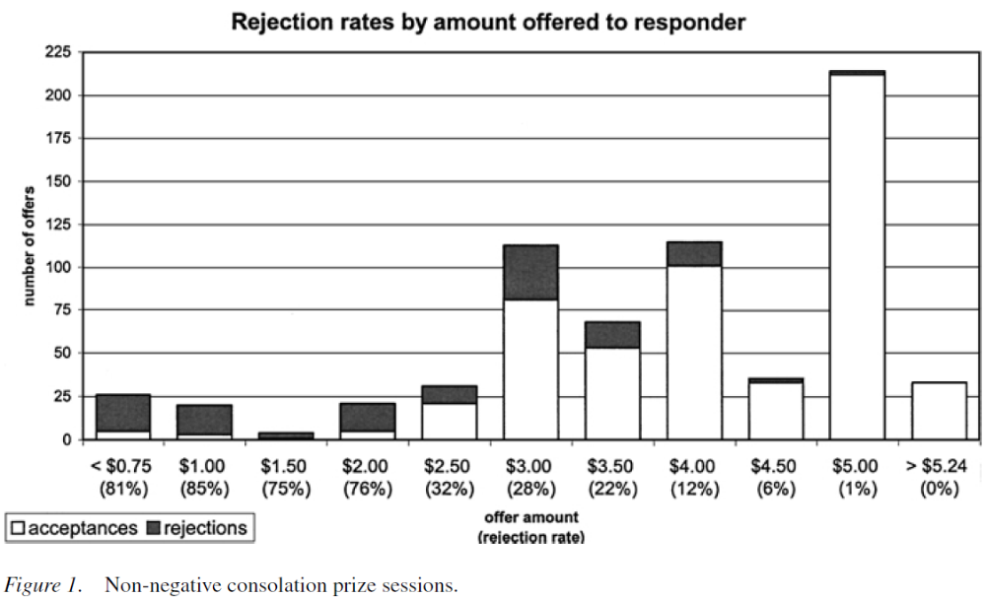
Figures for Dana et al.
